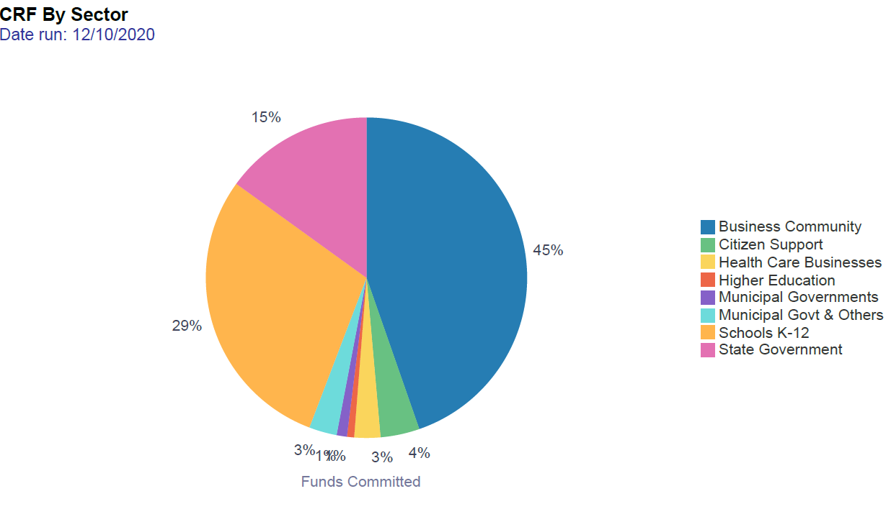
Coronavirus Relief Funds (CRF) by Sector as of December 10, 2020
Sector | Funds Committed | Total Expended or Encumbered | %
Business Community | $558,391,250 | $471,555,036 | 45%
Citizen Support | $49,186,000 | $15,000,000 | 4%
Health Care Businesses | $32,809,373 | $31,372,079 | 3%
Higher Education | $8,993,139 |  | 1%
Municipal Governments | $13,000,000 | $12,801,825 | 1%
Municipal Governments & Others | $35,000,000 | $2,051,075 | 3%
Schools K-12 | $364,775,530 | $331,805,520 | 29%
State Government | $187,844,708 | $107,345,030 | 15%
Grand Total | $1,250,000,000 | $971,930,565 | 100%

